This is a take-home exam in which you need to explain your answers clearly. Also, you need to take a maximum 30-minute video explaining your answers and give the link for your video in your submission. Grading will be based on your answers on the paper and in case of mis-explanation or similarity of your answers, you may not get the full point. The video is only for a proof incase there is a plagiarism attempt.

**Video Link:** <https://drive.google.com/file/d/1Nd-AYYmFGHPDek0XCF9M4AV_6c6TTREG/view?usp=sharing>

**Q1**. L = {w| w is a substring of infinite sequence occurring after the decimal point of 1/7} Prove or disprove that L is a regular language ( Σ = {0, 1, 2, 3, 4, 5, 6, 7, 8, 9})

Example: 1/7 = 0.142857142857142857… Thus “5714” is in the language while “1458” is not.

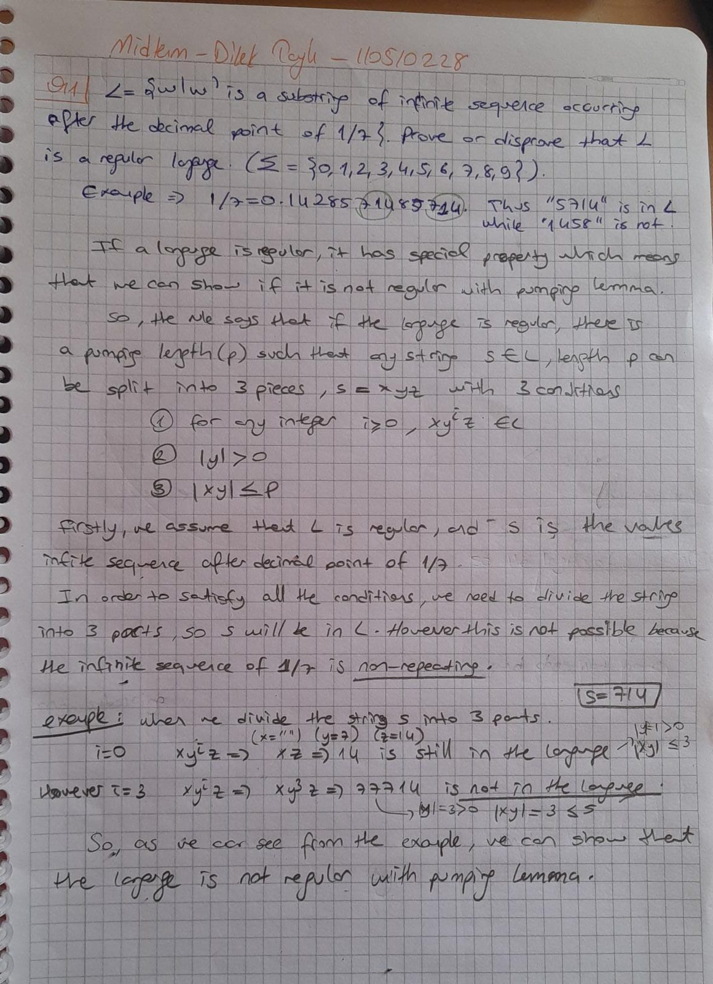

**Q2.** Design an NFA with ∑ = {0, 1} accepts all strings ending with 01.

**Q3.** Convert the regular expression; (a U ab+)∗ , to an NFA

**Q4.** Generate the regular expression recognized by the given DFA

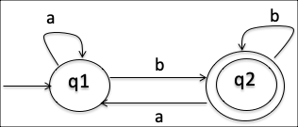

**Q5.** Convert the following nondeterministic finite automata to the equivalent deterministic finite automata. (Hint. The maximum number of states in the DFA will be 32. However, not all of them are accessible, thus, you do not need to put them in your DFA)

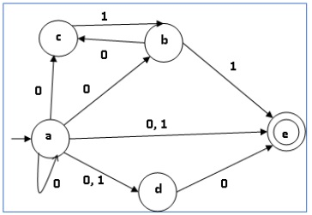

**Q6**. Find a CFG that generates the language:

L(G) = { 0n | n ≥ 0 and n is not multiple of 4 }.

**Q7.** Give the state diagram of the Push Down Automaton (PDA) for the language

L(G) = { anbmcm d2n | n ≥ 0, m > 0}.

**Q8.** Is it possible to find a regular expression describing the language generated by the following grammar? Why? If your answer is No, which rules are causing the problem? Note that the starting symbol of the grammar is S and the terminal alphabets are {x,y,z}.

S 🡪xA

A🡪yA | yB | zC

C🡪x | yB | z

B🡪zBZ | BD

D🡪xyzA | xyx

(in the next page)

